**Galileo** and EGNOS: supporting effective disaster management

***Published:***

*19 December 2019*

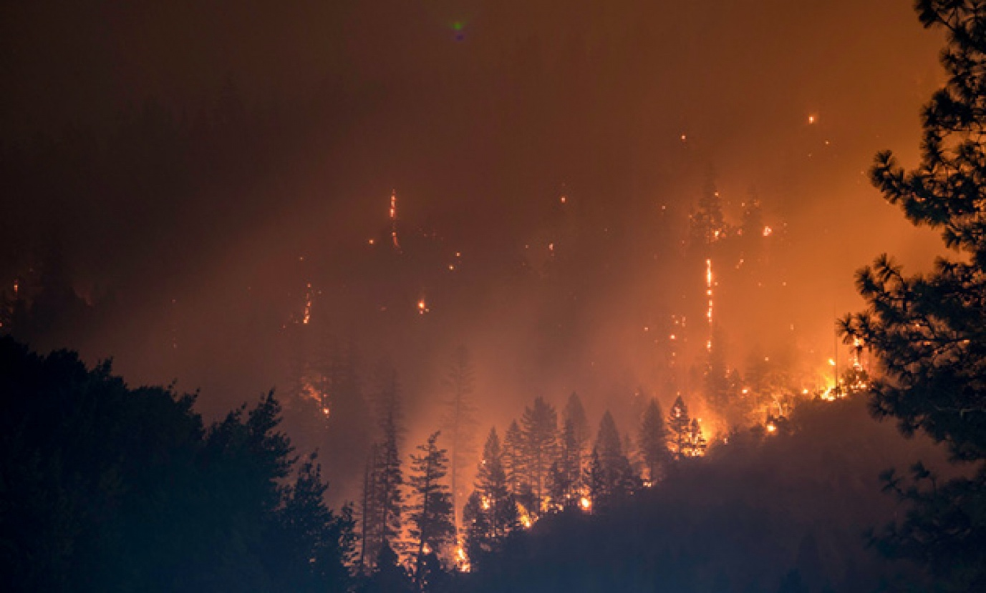

*Synergies between satellite observation, navigation and communications support the most effective disaster management response*

**When an emergency or a disaster hits a city or region, the priorities are to care for the wounded, restore infrastructure, provide logistics and basic services, and then to restore livelihoods and reconstruct communities. European GNSS – Galileo and EGNOS – supports applications and the delivery of critical services during the four key phases of the disaster management life cycle: preparedness, response, recovery, and mitigation.**

When it comes to effectively preparing for and managing the consequences of a disaster, it is important to have access to precise and up-to-date information. GNSS-based applications make a significant contribution during the preparation and mitigation phases of disaster management, supporting GNSS monitoring and early warning systems for disasters such as landslide or tsunami.

For the future, an EGNSS-based Emergency Warning Service is being considered as an additional service to support disaster management. The widespread use of Galileo receivers embedded in mobile phones means that the system can provide truly global early warnings and direct the civilian population in the event of an emergency.

**Response and recovery**

During the response and recovery phases of disaster management, rescue teams need guidance to use the routes that are still available to reach the affected areas. This requires detailed mapping and high accuracy navigation and positioning capabilities. High accuracy is especially needed under difficult circumstances that reduce visibility, such as fires, smoke or fog.

**Watch this:** [EGNOS for Helicopter Emergency Medical Services (HEMS)](https://www.gsa.europa.eu/library/videos?search=helicopter&field_video_gallery_topic_tid=All&field_video_gallery_language_value_1=All&sort_by=field_video_gallery_date_value&sort_by=field_video_gallery_date_value)

Here the upcoming Galileo High Accuracy Service (HAS) will make a difference, providing the accuracy needed to navigate drones and to enhance the navigation capability of search and rescue teams, while the Authenticated Open Service (OS-NMA) will provide additional robustness to the Galileo signals, foiling any attempt to disrupt rescue operations. EGNOS enabled PinS also increase access to helipads in poor visibility for Helicopter Emergency and Medical Services (HEMS).

**Drones for disaster response**

Responding to the need for an effective system for people location that can be used by disaster relief services in difficult terrain, the [MOBNET](http://mobnet-h2020.eu/) project is designing a system to locate isolated victims in the event of natural or man-made disasters. The system also can help first responder services to find lost people in the mountains.

**Read this:** [Integrating GNSS in UAVs for faster SAR](https://www.gsa.europa.eu/newsroom/news/integrating-gnss-uavs-faster-sar)

The MOBNET solution takes advantage of the ubiquity of mobile phones and the cost and performance gains of using drones in search and rescue operations, while leveraging the high-quality timing synchronisation capabilities provided by Galileo. Taking advantage of these three features, MOBNET uses digital cellular technologies to detect the presence of people, by locating their mobiles, and help rescuers in their search.

**Synergies in space**

Earth observation such as Copernicus is invaluable to detect fires or to map the extent of a disaster. Depending on the type of emergency, timely meteorological data from satellites and ground monitoring stations are also very useful in coping with the response.

EGNSS works along with Copernicus remote sensing and Earth observation to provide a comprehensive space-based approach to disaster management. Copernicus applications include short and long-term flood forecasting and a fire risk index, early warning alerts, insurance and rapid mapping of disaster areas during an emergency.

Communications links are also vital to coordinate and direct the rescue teams at a time when transportation infrastructure, including roads and bridges, may be severely damaged or impassable. Satellite communication allows the transfer of data when the usual communication infrastructures are disabled by the disaster event. Working in synergy, Copernicus, EGNSS and satellite communications provide the spatial awareness, connectivity and highly accurate positioning and navigation needed for an effective response.

**More success stories**

The [GEO-VISION](https://www.gsa.europa.eu/gnss-driven-eo-and-verifiable-image-and-sensor-integration-mission-critical-operational-networks) project (GNSS-driven EO and Verifiable Image and Sensor Integration for mission-critical Operational Networks) has developed the RAIDO and AGILE solutions to increase the situational awareness of emergency services and allow first responders to check the integrity of the GNSS signals they receive, increasing the efficiency of the emergency response and helping to save more lives.

Likewise, the [AIOSAT](http://www.aiosat.eu/) (Autonomous Indoor & Outdoor Safety Tracking System) project is developing a portable system that can be carried by first responders operating in a disaster zone. This system continuously transmits the position of the responders to a Mobile Coordination Centre, allowing them to effectively manage the situation and prevent rescue workers from taking risky actions.

In this way, the application counteracts some of the issues that arise with GNSS use in an emergency situation, such as a fire for example, where GNSS availability, reliability, and accuracy can be affected by the thick smoke, dense forests, rough terrain or the fact that responders are inside buildings.